**PROJECT REPORT**

**FOOD TRACKING SYSTEM**

|  |  |
| --- | --- |
| DATE | 27 October 2023 |
| TEAM ID | NM2023TMID01475 |
| PROJECT NAME | Food Tracking System |

# TEAM MEMBERS

|  |  |
| --- | --- |
| SAKTHI VIGNESH R | 812720103002 |
| ARJUN C | 812720103303 |
| MANIBALAN R | 812720103328 |
| KARTHI V | 812720103323 |

# 1. INTRODUCTION

Project Overview

Purpose

# 2. LITERATURE SURVEY

Existing problem

References

Problem Statement Definition

**3. IDEATION & PROPOSED SOLUTION**

Empathy Map Canvas

Ideation & Brainstorming

# 4. REQUIREMENT ANALYSIS

Functional requirement

Non-Functional requirements

# 5. PROJECT DESIGN

Data Flow Diagrams & User Stories

Solution Architecture

# 6. PROJECT PLANNING & SCHEDULING

Technical Architecture

Sprint Planning & Estimation

Sprint Delivery Schedule

# 7. CODING & SOLUTIONING

Feature 1

Feature 2

Database Schema (if Applicable)

1. **PERFORMANCE TESTING**

Performace Metrics

1. **RESULTS**

Output Screenshots

1. **ADVANTAGES & DISADVANTAGES**

1. **CONCLUSION**

# 12. FUTURE SCOPE

**13. APPENDIX** Source Code

GitHub & Project Demo Link

**1. INTRODUCTION**

# PROJECT OVERVIEW

The food industry is undergoing a significant transformation, with increasing demand for transparency and traceability throughout the supply chain. Food safety, authenticity, and sustainability are paramount concerns for consumers, regulators, and producers alike. Blockchain technology, with its decentralized and immutable ledger, offers a promising solution to address these concerns. This paper presents a novel approach to implementing a food tracking system using smart contracts on the Ethereum blockchain.

The proposed system leverages Ethereum's smart contract capabilities to create a transparent and secure platform for tracking food products from farm to fork. Each food item is assigned a unique digital identity, and its journey through the supply chain is recorded on the blockchain. This digital ledger ensures data integrity and enables real-time access to critical information such as origin, processing, and transportation details.

In today's fast-paced lifestyle, maintaining a healthy diet and keeping track of nutritional intake has become increasingly important. Our innovative food tracking system is designed to provide users with a comprehensive solution for monitoring their dietary habits and achieving their nutritional goals. By leveraging advanced technologies, our system offers a user-friendly interface that allows individuals to effortlessly record their food consumption, track calorie intake, and analyze nutritional content. With customizable features and insightful data visualization, our platform aims to empower users to make informed choices about the diet and promote a healthier lifestyle.

# PURPOSE

In an era of heightened consumer awareness and demand for transparency in the food supply chain, the integration of blockchain technology has emerged as a revolutionary solution. Our pioneering food tracking system harnesses the power of blockchain to ensure the traceability, authenticity, and safety of food products from farm to table. By leveraging the immutable and decentralized nature of blockchain, our system enables stakeholders to securely record and verify every step of the food production and distribution process, providing consumers with real-time access to comprehensive and trustworthy information about the origins and quality of their food. With an emphasis on enhancing food safety, supply chain efficiency, and consumer confidence, our blockchain-based solution is poised to transform the way we perceive and interact with the food industry.

**2. LITERATURE SURVEY**

# EXISTING PROBLEM

1. IBM Food Trust: IBM Food Trust is a blockchain-based food tracking system that allows participants in the supply chain, including growers, suppliers, retailers, and consumers, to trace the origin and journey of food products. It provides transparency and traceability to ensure food safety and quality.

1. VeChain: VeChain is a blockchain platform that has a dedicated solution called VeChain ToolChain for supply chain management. It can be used for tracking and tracing food products from farm to table, ensuring authenticity and quality.
2. Provenance: Provenance is a blockchain-based platform that helps businesses and consumers track the origin and journey of products, including food. It provides information on the provenance of the product, certifications, and sustainability information.

1. TE-FOOD: TE-FOOD is a food traceability system that uses blockchain and other technologies to provide end-to-end visibility in the food supply chain. It's particularly focused on ensuring food safety and reducing fraud.

1. OriginTrail: OriginTrail is a blockchain-based protocol for supply chain management and data sharing. It can be used to track and trace food products, providing transparency and trust in the supply chain.

1. Ambrosus: Ambrosus is a blockchain platform designed for food and pharmaceutical supply chains. It offers features like IoT integration, smart contracts, and sensors to ensure the quality and safety of food products.

# REFERENCES

1. J. Van der Vorst, “Effective food supply chains; generating, modelling and evaluating supply chain scenarios,” Wagening. Univ. Promot. Profir AJM Beulens N Profdr P Van Beek - Wagening. Vorst 2000 - ISBN 90 5808 26 -X, Jan. 2000.

1. M. C. Cooper and L. M. Ellram, “Characteristics of Supply

Chain Management and the Implications for Purchasing and

Logistics Strategy,” Int. J. Logist. Manag., vol. 4, no. 2, pp. 13–24, Jan. 1993, doi: 10.1108/09574099310804957.

1. F. Yiannas, “A New Era of Food Transparency Powered by Blockchain,” Innov. Technol. Gov. Glob., vol. 12, no. 1–2, pp.

46–56, Jul. 2018, doi: 10.1162/inov_a_00266.

1. L. Manning, R. N. Baines, and S. A. Chadd, “Quality assurance models in the food supply chain,” Br. Food J., vol.

108, no. 2, pp. 91–104, Jan. 2006, doi:

10.1108/00070700610644915.

1. M. Fritz and G. Schiefer, “Food chain management for sustainable food system development: a European research agenda,” Agribusiness, vol. 24, no. 4, pp. 440–452, 2008, doi:

[https://doi.org/10.1002/agr.20172.](https://doi.org/10.1002/agr.20172)

1. J. Gustavsson, C. Cederberg, and U. Sonesson, Global food losses and food waste: extent, causes and prevention ; study conducted for the International Congress Save Food! at Interpack 2011, [16 - 17 May], Düsseldorf, Germany. Rome: Food and Agriculture Organization of the United Nations, 2011.

1. Tipmontian, Alcover, and Rajmohan, “Impact of Blockchain Adoption for Safe Food Supply Chain Management through System Dynamics Approach from Management

Perspectives in Thailand,” Proceedings, vol. 39, no. 1, p. 14, Jan. 2020, doi: 10.3390/proceedings2019039014.

1. P. Brereton, B. A. Kitchenham, D. Budgen, M. Turner, and M. Khalil, “Lessons from applying the systematic literature review process within the software engineering domain,”

J. Syst. Softw., vol. 80, no. 4, pp. 571–583, Apr. 2007, doi:

10.1016/j.jss.2006.07.009.

1. K. Salah, N. Nizamuddin, R. Jayaraman, and M. Omar, “Blockchain-Based Soybean Traceability in Agricultural Supply Chain,” IEEE Access, vol. 7, pp. 73295–73305, 2019, doi:
2. A. Shahid, A. Almogren, N. Javaid, F. A. Al-Zahrani, M. Zuair, and M. Alam, “Blockchain-Based Agri-Food Supply Chain:

A Complete Solution,” IEEE Access, vol. 8, pp. 69230–69243, 2020, doi: 10.1109/ACCESS.2020.2986257.

# PROBLEM STATEMENT DEFINITION

The problem statement for a food tracking system in blockchain technology outlines the specific challenges and issues that the system aims to address. It typically defines the core problems within the existing food supply chain that can be resolved through the implementation of blockchain-based tracking. Here is an example of a problem statement for a food tracking system in blockchain:

Current food supply chains often lack transparency and reliability, leading to challenges in ensuring the authenticity, safety, and traceability of food products from farm to table. Existing systems face issues such as data inconsistencies, limited accountability, and difficulties in verifying the origins and quality of food items, which can compromise consumer trust and food safety standards. As a result, there is a pressing need for a robust and secure food tracking system that leverages blockchain technology to establish a transparent, immutable, and efficient method for tracking the entire food supply chain, ensuring data integrity, and enhancing consumer confidence in the quality and authenticity of food products.

**3. IDEATION & PROPOSED SOLUTION**

# EMPATHY MAP CANVAS

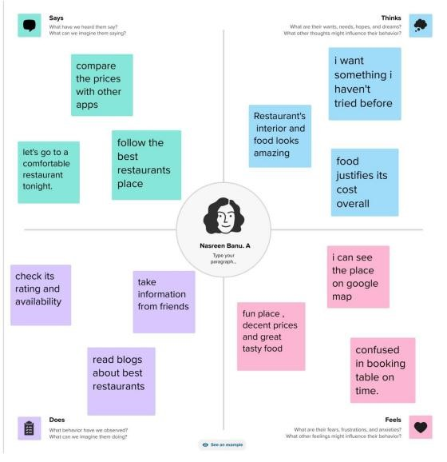

# IDEATION & BRAINSTORMING

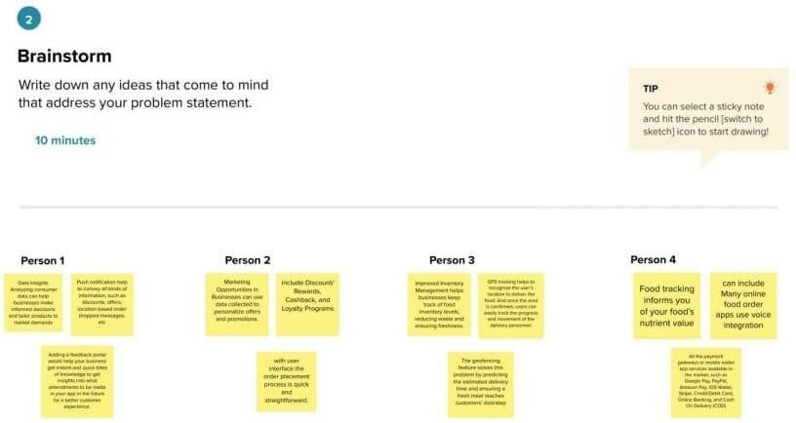

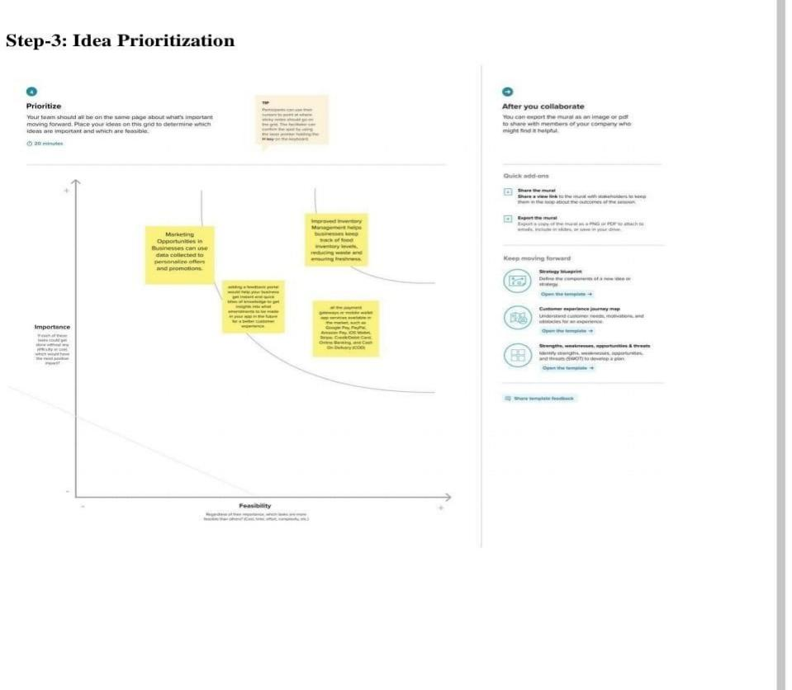

**4. REQUIREMENT ANALYSIS**

# FUNCTIONAL REQUIREMENTS

1. Product Traceability: The system should enable end-to-end traceability of food products, allowing stakeholders to track the journey of each product through the supply chain.

1. Immutable Recordkeeping: The system should maintain an immutable ledger that records all transactions and events related to the production, processing, and distribution of food items.

1. Authentication and Verification: The system should provide mechanisms for authenticating and verifying the authenticity and quality of food products at each stage of the supply chain.
2. Real-time Data Sharing: The system should facilitate real-time sharing of data among stakeholders, ensuring that all participants have access to accurate and up-to-date information about the status and location of food products.

1. Smart Contract Integration: The system should integrate smart contracts to automate and enforce contractual agreements and obligations between participants in the food supply chain.

1. Quality Control Management: The system should incorporate features for monitoring and managing quality control processes, including inspections, certifications, and compliance with regulatory standards.

1. User Access Control:The system should implement user access controls to ensure that only authorized participants have permission to view and update specific information within the blockchain network.

1. Data Analytics and Reporting: The system should offer data analytics and reporting capabilities to analyze trends, patterns, and anomalies within the food supply chain, enabling stakeholders to make informed decisions and improve operational efficiency.

1. Interoperability with Existing Systems: The system should be designed to integrate seamlessly with existing food tracking systems and databases, allowing for a smooth transition and data migration process.

1. Compliance with Regulatory Standards: The system should adhere to relevant regulatory standards and compliance requirements within the food industry, ensuring that data management and sharing practices align with legal and ethical guidelines.

# NON-FUNCTIONAL REQUIREMENTS

1. Security: The system should ensure a high level of security to protect the integrity and confidentiality of data, preventing unauthorized access, tampering, or data breaches.

1. Scalability: The system should be designed to handle a large volume of transactions and data with the ability to scale seamlessly to accommodate the growing needs of the food supply chain.

1. Performance: The system should demonstrate high performance, ensuring fast transaction processing, minimal latency, and quick data retrieval for efficient tracking and management of food products.

1. Reliability: The system should be highly reliable, with minimal downtime and a robust disaster recovery plan in place to ensure continuous availability and access to critical data.

1. Interoperability: The system should be interoperable with other blockchain networks and technologies, allowing for seamless integration and data exchange with external systems and applications.

1. Compliance: The system should comply with industry standards, regulatory requirements, and data protection laws to ensure that data management and sharing practices align with legal and ethical guidelines.

1. Usability: The system should offer a user-friendly interface with intuitive navigation, clear data visualization, and comprehensive documentation to facilitate ease of use and smooth adoption by stakeholders.
2. Auditability: The system should support comprehensive audit trails and reporting capabilities, enabling the tracking and monitoring of all system activities for accountability and regulatory compliance purposes.

1. Data Integrity: The system should maintain the integrity of data stored on the blockchain, ensuring that all information remains accurate, consistent, and tamper-proof throughout the entire supply chain process.

1. Regulatory Compliance: The system should adhere to regulatory standards and industry guidelines, ensuring that all recorded data and transactions comply with relevant food safety and traceability regulations.

**5. PROJECT DESIGN**

# DATA FLOW DIAGRAM & USER STORIES

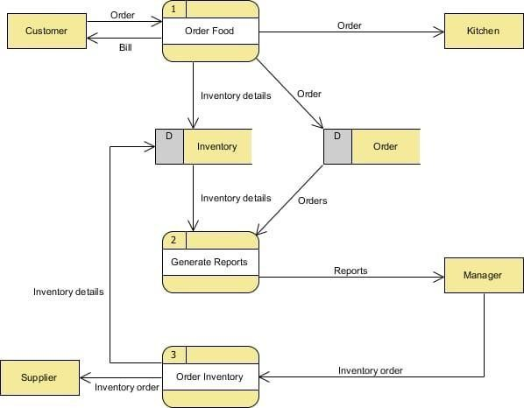

# SOLUTION ARCHITECTURE

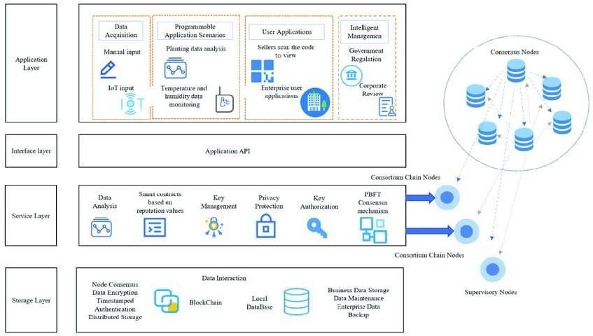

**6. PROJECT PLANNING & SCHEDULING**

# TECHNICAL ARCHITECTURE

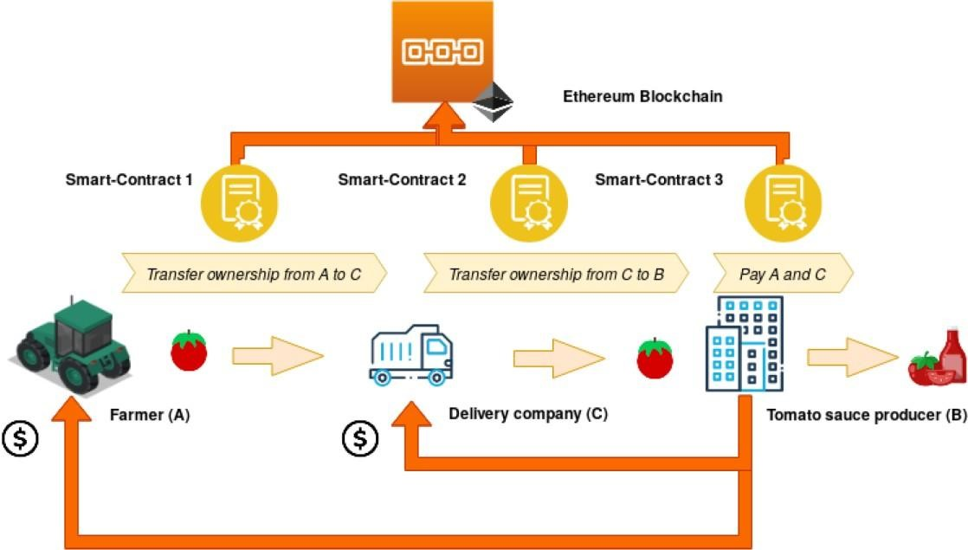

# SPRINT PLANNING & ESTIMATION

**Sprint Planning**:

1. Product Backlog Refinement: Start with refining the product backlog, which is a prioritized list of features, user stories, and tasks. Ensure that the most critical and valuable items are at the top of the backlog.

1. Sprint Duration: Decide on the sprint duration. Common durations are 2-4 weeks, but it can vary based on the project's complexity and the team's velocity.

1. Sprint Goal: Define a sprint goal for each sprint. For a food tracking system, it could be something like "Implement end-to-end product tracking for a specific food item."

1. Sprint Backlog: Select the top items from the product backlog that align with the sprint goal. These items will become your sprint backlog for the upcoming sprint.

1. Task Breakdown: For each item in the sprint backlog, break them down into smaller, actionable tasks. Tasks might include designing, coding, testing, and documentation.

1. Estimation: Estimate the effort required for each task. Common estimation techniques include story points, ideal days, or hours. The team should reach a consensus on these estimates.

1. Assign Tasks: Assign tasks to team members based on their skills and availability. Ensure that the team collectively owns the sprint backlog.

Sprint Execution:

During the sprint, the team will work on completing the tasks from the sprint backlog. Daily stand-up meetings can be used to track progress and discuss any impediments or issues.

Sprint Review:

At the end of the sprint, the team should hold a sprint review meeting to showcase the work completed during the sprint. Stakeholders can provide feedback, and the product owner can decide whether to accept the work or not.

Sprint Retrospective:

Conduct a sprint retrospective to reflect on what went well and what could be improved in the next sprint. This helps the team continuously adapt and improve their processes.

Repeat:

Repeat the sprint planning, execution, review, and retrospective process for subsequent sprints until the project is completed.

**Estimation Techniques:**

Story Points: Assign relative values (story points) to user stories or tasks. The team estimates based on complexity, effort, and risk.

Planning Poker: A collaborative technique where team members use a deck of cards with numbers representing effort. It helps reach a consensus on estimates.

Ideal Days: Estimate tasks based on how many ideal working days it will take to complete them.

Hours: Estimate tasks in hours. This approach provides a more granular view of effort.

# SPRINT DELIVERY SCHEDULE

The schedule can vary based on the complexity of the project, team capacity, and specific requirements. A typical sprint duration is 2-4 weeks.

**Sprint 1**: Setting Up the Environment Duration: 2 weeks Goals:

* Set up the blockchain network environment (e.g., Hyperledger Fabric, Ethereum).
* Create a basic smart contract for product creation and registration.
* Develop a simple user interface for product registration.

Deliverables:

* A functioning blockchain network.
* Smart contract for product registration.
* Basic product registration interface.

**Sprint 2**: Basic Product Tracking Duration: 3 weeks Goals:

* Enhance the smart contract to include basic product tracking (e.g., timestamps, location).
* Develop a user interface for product tracking.
* Implement basic supply chain data integration with IoT devices (e.g., temperature sensors, GPS trackers).

Deliverables:

* Smart contract with enhanced tracking capabilities.
* User interface for tracking products.
* Basic IoT data integration.

**Sprint 3**: Identity and Security Duration: 3 weeks Goals:

* Implement decentralized identity for participants.
* Enhance security features, including authentication and authorization.
* Set up a blockchain explorer for transparency.

Deliverables:

* Decentralized identity integration.
* Improved security measures.
* Blockchain explorer for auditing.

**Sprint 4**: Quality and Compliance Duration: 4 weeks Goals:

* Integrate quality control data into the system.
* Implement verification of certifications and inspections.
* Ensure compliance with relevant food safety regulations.

Deliverables:

* Quality control data integration.
* Verification of certifications and inspections.
* Compliance features.

**Sprint 5**: User-Facing Features Duration: 3 weeks Goals:

* Develop consumer-facing mobile apps and web interfaces for product tracking and verification.
* Enable consumers to access information about scanned products.

Deliverables:

* Consumer-facing mobile and web applications.
* QR code scanning and product information display.

**Sprint 6**: Integration and Scalability Duration: 4 weeks Goals:

* Integrate the blockchain system with legacy supply chain management and ERP systems.
* Ensure scalability and performance optimization.

Deliverables:

* Successful integration with legacy systems.
* Scalability improvements.

**Sprint 7**: Analytics and Reporting Duration: 3 weeks Goals:

* Implement monitoring and analytics tools to gain insights into the supply chain.
* Generate reports for stakeholders.

Deliverables:

* Monitoring and analytics tools.
* Customized reports.

**Sprint 8**: Final Testing and Refinement - Duration:2 weeks - Goals:

* Perform thorough testing and address any issues.
* Refine the user interfaces and functionality based on feedback.

Deliverables:

* A thoroughly tested and refined system.

**Sprint 9**: Documentation and Training Duration: 2 weeks Goals:

* Create user documentation and training materials.
* Train users and stakeholders on how to use the system effectively.

Deliverables:

* Comprehensive documentation.
* Trained users.

**Sprint 10**: Deployment Duration: 2 weeks Goals:

* Deploy the system in a production environment.
* Ensure a smooth transition from any existing systems.

Deliverables:

* A fully deployed and operational blockchain-based food tracking system.

**7. CODINGN & SOLUTIONING**

# FEATURES 1

1. Product Registration:

- Each food product is registered on the blockchain with unique identifiers.

-Include details such as product name, batch/lot number, and producer information.

1. Supply Chain Visibility:

-Real-time tracking of product movement throughout the supply chain.

-Information on the product's origin, location, and journey.

1. IoT Integration:
   * Integration with Internet of Things (IoT) devices for data collection (e.g., temperature, humidity, GPS).
   * Ensure data from sensors is recorded on the blockchain for transparency.

1. Decentralized Identity:
   * Each participant in the supply chain has a verifiable and unique identity on the blockchain.
   * Ensures trust and accountability in the system.

1. Smart Contracts:
   * Automation of supply chain processes through smart contracts.
   * Trigger actions such as quality checks, certifications, and ownership transfers.

1. Verification of Certifications:
   * Ability to verify the authenticity of certifications (e.g., organic, halal, kosher) directly on the blockchain.

1. Quality Control Data:
   * Recording and tracking of quality control data at various checkpoints in the supply chain.
   * Include factors like temperature, humidity, and handling conditions.

1. Consumer Access:
   * Enable consumers to access product information by scanning QR codes or using mobile apps.
   * Information on the product's journey and quality.

1. Blockchain Explorer:
   * A user-friendly tool for viewing the blockchain's transaction history and product details.
   * Transparency for all stakeholders.

1. Compliance and Regulations:
   * Ensure compliance with food safety regulations and standards (e.g., FDA regulations, FSMA in the United States).
   * Automated reporting for regulatory purposes.

1. Immutable Records:
   * All data recorded on the blockchain is tamper-proof and immutable.
   * Important for traceability and accountability.

1. Interoperability:
   * Standards for data exchange with other blockchain networks and legacy systems.
   * Facilitate integration with existing supply chain management software.

1. Security:
   * Robust security measures, including encryption, authentication, and authorization.
   * Use of digital signatures to verify transaction authenticity.

1. Scalability:
   * Design the system to handle a large volume of transactions and data as the supply chain grows.

1. Analytics and Reporting:
   * Monitoring and analytics tools to gain insights into the supply chain.
   * Generate reports for stakeholders to make informed decisions.

1. Legacy System Integration:
   * Ensure compatibility with legacy supply chain management systems and ERP software.
   * Facilitate a smooth transition to the blockchain system.

1. Task Automation:
   * Automation of routine tasks, such as product verification and data entry, through smart contracts.

1. Mobile and Web Interfaces:
   * User-friendly interfaces for participants and consumers to interact with the system.

1. User and Role Management:
   * Role-based access control to ensure that users have the appropriate permissions.

1. Documentation and Training:
   * Comprehensive user documentation and training materials for system users.

# FEATURE 2

1.Decentralization

With blockchain the information is distributed across the network rather than at one central point. This also makes the control of information to be distributed and handled by consensus reached upon by shared input from the nodes connected on the network. The data that was before concentrated at one central point is now handled by many trusted entities.

2) Data Transparency

Achieving data transparency in any technology is to have a trust based relationship between entities. The data or record at stake should be secured and temper proof. Any data being stored on the blockchain is not concentrated at one place and is not controlled by one node but is instead distributed across the network. The ownership of data is now shared and this makes it to be transparent and secure from any third party intervention.

3. Security and Privacy

Blockchain technology uses cryptographic functions to provide security to the nodes connected on its network. It uses SHA-256 cryptographic algorithm on the hashes that are stored on the blocks. SHA stands for Secure Hashing Algorithm, these hashes provide security to the blockchain as data integrity is ensured by them. Cryptographic hashes are strong one way functions that generate checksum for digital data that cannot be used for data extraction. This makes blockchain as such a decentralized platform made secure by the cryptographic approaches which makes it to be a good option for privacy protection of certain applications

**8. PERFORMANCE TESTING**

# PERFORMANCE METRICS

Performance metrics for a food tracking system can vary depending on the specific goals and requirements of the system. However, here are some common performance metrics that can be considered when evaluating the effectiveness of a food tracking system:

1. Accuracy: Accuracy measures how well the system correctly identifies and records the foods that users consume. It is often expressed as a percentage and is calculated by dividing the number of correctly identified foods by the total number of foods recorded.

1. Precision: Precision measures the system's ability to correctly identify true positive food items while minimizing false positives. In the context of food tracking, precision reflects how often the system correctly recognizes and records the foods users consume.

1. Recall (Sensitivity): Recall measures the system's ability to identify all relevant food items, including true positives, while minimizing false negatives. It is particularly important for capturing all the foods users eat.

1. F1 Score: The F1 score is the harmonic mean of precision and recall and provides a balance between these two metrics. It can be useful for systems where both false positives and false negatives are important to consider.

1. Specificity: Specificity measures the system's ability to correctly identify true negative food items, which are foods that were not consumed. It's important to minimize false positives in this context.

1. User Satisfaction: This metric measures user satisfaction with the system. You can collect feedback from users through surveys or user ratings to assess how well the system meets their needs and expectations.

1. Real-Time Data Entry: Assess how quickly the system allows users to input their food consumption data. A faster and more efficient data entry process can lead to better user experiences.
2. Data Completeness: Evaluate how often users are able to log all their meals and snacks. Incomplete data can affect the system's accuracy and usefulness.

1. Data Consistency: Check for consistency in data entry, such as standardizing food names, portion sizes, and meal times. Inconsistent data can lead to inaccuracies.

1. Integration with Wearables: If the system integrates with wearable devices, assess how well it captures data from these devices, such as fitness trackers or smartwatches.

1. Food Recognition Speed: Measure the time it takes for the system to recognize and log a food item. Faster recognition can enhance the user experience.

1. Database Coverage: Evaluate the breadth of the system's food database. A comprehensive database with a wide range of food items can improve the accuracy of food recognition.

1. Privacy and Security: Assess the system's security features to ensure that users' food consumption data is protected.

1. Data Visualization: Evaluate the effectiveness of the data presentation, including charts and reports, to help users understand their food consumption patterns.

1. Error Rate: Measure the rate of incorrect food identifications or data entry errors. Minimizing errors is crucial for accurate tracking.

1. Machine Learning Model Performance: If the system uses machine learning for food recognition, assess the model's performance, including its precision, recall, and F1 score.

**9. RESULTS**

# OUTPUT SCREENSHOTS

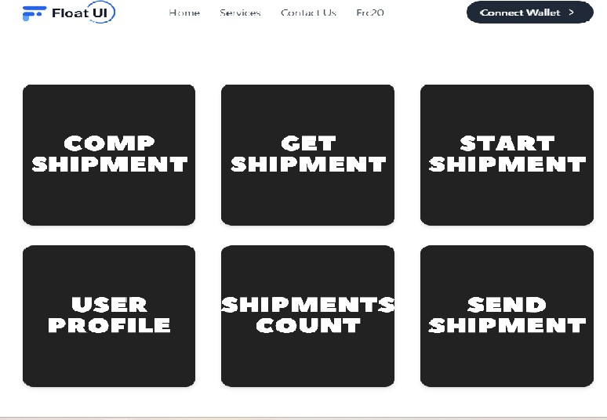

**10. ADVANTAGES & DISADVANTAGES**

# ADVANTAGES

1. Improved Awareness: Food tracking helps users become more aware of what they eat and drink. It encourages mindfulness about food choices and portion sizes, which can lead to healthier eating habits.

1. Weight Management: Food tracking is a valuable tool for weight management. It allows users to track their calorie intake, helping them achieve weight loss or maintenance goals by creating a calorie deficit or surplus.

1. Nutritional Balance: Users can monitor their intake of essential nutrients, such as proteins, fats, carbohydrates, vitamins, and minerals, ensuring they meet their nutritional needs.

1. Allergen and Dietary Restriction Management: Food tracking can be especially useful for individuals with allergies, dietary restrictions, or specific health conditions (e.g., diabetes, celiac disease). It helps them avoid allergens and manage their condition through accurate food monitoring.

1. Goal Setting: Food tracking systems often allow users to set dietary and health goals, such as daily calorie targets, macronutrient ratios, or specific dietary plans. Tracking progress toward these goals can be motivating.

1. Accountability: Users can hold themselves accountable for their dietary choices. Knowing that they'll record what they eat can deter unhealthy snacking or overeating

1. Behavioral Change: Over time, food tracking can lead to behavior change. Users may naturally gravitate toward healthier food choices and portion control as they see the impact of their choices on their health and fitness goals.

1. Identifying Patterns: Tracking data over an extended period allows users to identify eating patterns and triggers. They can learn about their eating habits and make adjustments accordingly.

1. Customization: Many food tracking systems offer customization options, allowing users to input their dietary preferences, allergies, and restrictions, ensuring that the system aligns with their unique needs.

1. Data-Driven Decision-Making: Users can make informed decisions about their food choices based on the data they collect. For example, they can see which foods are contributing to their calorie intake and make substitutions accordingly.

1. Community and Social Support: Some food tracking systems include social features where users can connect with friends or a community. This social support can help individuals stay motivated and share experiences.

1. Professional Guidance: Some systems offer integration with healthcare professionals, nutritionists, or dietitians, allowing for remote monitoring and support.

1. Long-Term Health Benefits: Consistent food tracking can contribute to long-term health benefits, such as reduced risk of chronic diseases, improved digestion, and better overall well- being.

1. Fitness and Athletic Performance: For athletes and fitness enthusiasts, tracking food intake can help optimize energy levels, nutrient timing, and recovery.

1. Research and Insights: Aggregate data from food tracking systems can provide valuable insights for researchers and public health organizations. This data can inform policies and recommendations.

1. Convenience: Food tracking systems are often convenient to use, with the ability to scan barcodes, search for foods, and store favorite meals for quick entry.
2. Visual Feedback: Many systems provide visual charts and reports that make it easy for users to see their progress and trends over time.

1. Mood and Energy: Users may discover how their diet affects their mood and energy levels, leading to adjustments that enhance their overall quality of life.

# DISADVANTAGES

1. Time-Consuming: Tracking every meal and snack can be time- consuming, especially for people with busy schedules. It requires a commitment to logging food consistently.

1. Inaccuracy: Accuracy in tracking can be challenging, as it relies on users' estimates of portion sizes and the completeness of the food database. Inaccurate data can lead to unreliable results.

1. Obsessive Behavior: For some individuals, food tracking can become an obsession, leading to unhealthy eating habits or the development of eating disorders like orthorexia or anorexia nervosa.

1. Stress and Anxiety: The pressure to meet daily calorie or nutrient goals can lead to stress and anxiety, causing users to become overly fixated on their diets.

1. Limited Food Database: The comprehensiveness of the food database can vary between different tracking systems. Users may struggle to find certain regional or homemade foods.
2. Social Awkwardness: Constantly logging food in social situations can be socially awkward or lead to social isolation. It may also detract from the enjoyment of meals with friends and family.

1. User Compliance: Some users may find it challenging to consistently track their food intake, leading to incomplete or inconsistent data, which can impact the system's effectiveness.

1. Privacy Concerns: Users may have concerns about the privacy and security of their dietary data, particularly when using apps or websites that collect personal information.

1. Overemphasis on Numbers: Users may become overly focused on numbers (calories, macros, etc.) rather than the quality of their food choices. This can lead to unhealthy dietary decisions.

1. Lack of Context: Food tracking systems often don't consider the broader context of eating, such as emotional eating, cravings, or social influences on food choices.

1. Dependency: Some users may become overly dependent on food tracking apps and lose the ability to make intuitive, mindful food choices without the app.

1. Cost: While many food tracking apps offer free versions, premium features or subscriptions can incur additional costs.

1. Technology and Accessibility: Not everyone has access to smartphones or the internet, which can limit the use of these systems, particularly in underserved communities.
2. Food Quality vs. Quantity: Food tracking tends to focus on quantity (calories, macros) rather than the quality of the food. Users may prioritize low-calorie processed foods over nutrient- dense whole foods.

1. Unrealistic Expectations: Food tracking can sometimes foster unrealistic expectations about weight loss and body image, potentially leading to disappointment or body dissatisfaction.

1. Eating Disorders Trigger: For individuals with a history of eating disorders or disordered eating patterns, food tracking can be a trigger for relapse.

1. Loss of Spontaneity: Users may feel that they lose the spontaneity and pleasure of eating when they have to meticulously track every morsel they consume.

1. Not Suitable for Everyone: Food tracking may not be appropriate for people with certain medical conditions or mental health issues. It's important to consult with healthcare professionals for personalized advice.

# 11. CONCLUSION

The application is based on user’s requirement and is user centered. All issues related to all user which are included in this system are developed by this system. If people know how to operate android smart phone wide variety of people can use the application. This system will solve the various issues related to tracking the Food service. To help and solve important problems of people implementation of Online Food Tracking system is done. It can be concluded that, based on the application: Tracking of food is easily by this system; Information needed in making order to customer is provided by the system. Receiving orders and tracking the food is possible through the application and it also helps admin in controlling all the Food system.

# 12. FUTURE SCOPE

1. Personalized Nutrition: Food tracking systems are likely to become more personalized, taking into account an individual's unique dietary preferences, health goals, genetics, and lifestyle. Machine learning and AI algorithms can help provide tailored dietary recommendations.

1. Integration with Wearable Devices: The integration of food tracking with wearable devices and sensors will continue to grow. Devices like smartwatches and fitness trackers can provide real- time data on physical activity, heart rate, and even metabolic information, enhancing the accuracy of calorie expenditure calculations.

1. Biofeedback: Advancements in biofeedback technology may enable real-time monitoring of physiological responses to food. This can provide insights into how different foods affect an individual's body, helping with personalized dietary choices.

1. Meal Planning and Preparation: Food tracking systems may expand to offer meal planning and preparation features, helping users create and follow balanced meal plans based on their dietary goals and preferences.

1. Nutrient Quality Assessment: Future systems could place a greater emphasis on nutrient quality rather than just calorie counting, helping users make healthier food choices based on their nutritional value.
2. AI-Powered Food Recognition: Improved AI algorithms will enhance the accuracy and speed of food recognition. Users may simply need to take a photo of their meal, and the system can accurately identify and log the foods.

1. Blockchain for Food Traceability: Blockchain technology can be used to provide a transparent and secure way to trace the origin of food products. This can help users make informed choices about the sources and quality of their food.

1. Augmented Reality (AR) Integration: AR can be used to provide users with real-time information about the nutritional content of foods by simply pointing a smartphone or smart glasses at the food item.

1. Healthcare Integration: Food tracking systems may integrate more closely with healthcare providers. Physicians and dietitians can access a patient's food intake data remotely, enabling more targeted recommendations and monitoring.

1. Behavioral Psychology Integration: Behavioral psychology principles can be incorporated into food tracking systems to address psychological aspects of eating, such as emotional eating, cravings, and habit formation.

**13. APPENDIX**

**SOURCE CODE**

# Food Tracking.sol

// SPDX-License-Identifier: MIT pragma solidity ^0.8.0;

contract FoodTracking {

address public owner;

enum FoodStatus {

Unverified,

Verified,

Consumed

}

struct FoodItem { string itemId; string productName;

string origin; uint256 sentTimestamp; FoodStatus status;

} mapping(string => FoodItem) public foodItems;

event FoodItemSent( string indexed itemId, string productName, string origin, uint256 sentTimestamp

);

event FoodItemVerified(string indexed itemId);

event FoodItemConsumed(string indexed itemId);

constructor() {

owner = msg.sender;

}

modifier onlyOwner() {

require(msg.sender == owner, "Only contract owner can call

this");

_;

}

modifier onlyUnconsumed(string memory itemId) { require( foodItems[itemId].status == FoodStatus.Verified,

"Item is not verified or already consumed"

);

_;

}

function sendFoodItem( string memory itemId, string memory productName, string memory origin

) external onlyOwner { require( bytes(foodItems[itemId].itemId).length == 0,

"Item already exists"

);

foodItems[itemId] = FoodItem({ itemId: itemId, productName: productName, origin: origin,

sentTimestamp: block.timestamp,

status: FoodStatus.Unverified

});

emit FoodItemSent(itemId, productName, origin, block.timestamp);

}

function verifyFoodItem(string memory itemId) external

onlyOwner { require( bytes(foodItems[itemId].itemId).length > 0,

"Item does not exist"

);

require( foodItems[itemId].status == FoodStatus.Unverified,

"Item is already verified or consumed"

);

foodItems[itemId].status = FoodStatus.Verified;

emit FoodItemVerified(itemId);

}

function consumeFoodItem(

string memory itemId

) external onlyUnconsumed(itemId) { foodItems[itemId].status = FoodStatus.Consumed;

emit FoodItemConsumed(itemId);

}

function getFoodItemDetails(

string memory itemId

)

external view

returns (string memory, string memory, uint256, FoodStatus) {

FoodItem memory item = foodItems[itemId];

return (item.productName, item.origin, item.sentTimestamp,

item.status); }

}